Network Cables & Tasks Assignment

Task-1:
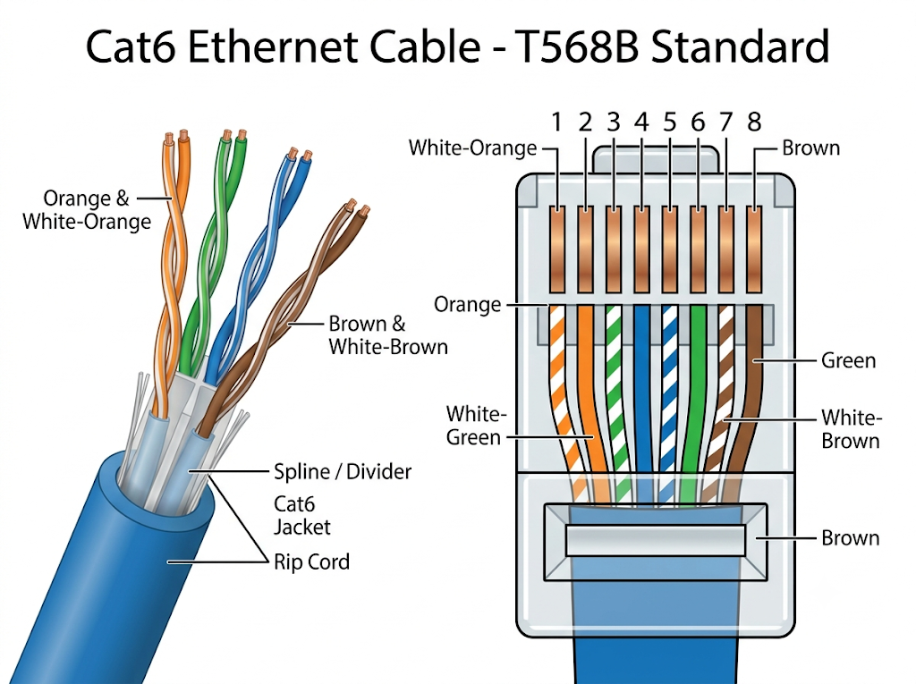

Task-2:
1. Cat5e (Category 5e)
Application: Zomato POS Terminal at a restaurant or café.
Why: Cat5e supports up to 1 Gbps speeds, which is more than enough for processing small POS transactional data. It is flexible, cost-effective, and easy to route tightly behind counters.
2. Cat6 (Category 6)
Application: High-Speed WiFi 6 Router in an office.
Why: Cat6 has tighter twists and better internal shielding to prevent crosstalk. It supports up to 10 Gbps over shorter distances, making it ideal for connecting a modern router to a fiber modem without bottlenecking the local network speeds.
3. Fiber Optic
Application: IPL Streaming Server Backbone / Data Center.
Why: Fiber optics use light pulses to transmit data, offering massive bandwidth and ultra-low latency over long distances. It is completely immune to electromagnetic interference (EMI), which is essential for smoothly broadcasting live HD sports to millions of concurrent viewers.

Task-3:
1. Strip the jacket: Use a stripping tool to carefully remove about 1.5 inches of the outer
cable jacket without cutting the inner wires.
2. Untwist and arrange: Separate the four twisted pairs, untwist them, and arrange them in
a flat line according to the T568B color code (White/Orange, Orange, White/Green, Blue,
White/Blue, Green, White/Brown, Brown).
3. Trim wires: Cut the wires straight across in a perfect line, leaving about 0.5 inches of
exposed wire.
4. Insert into RJ-45: Push the aligned wires into the clear RJ-45 connector, ensuring each
wire reaches the very end of its respective groove.
5. Crimp: Insert the connector into the crimping tool and squeeze firmly to drive the gold
pins into the wires and lock the strain relief clip.
6. Test: Use a basic cable tester to verify all 8 pins show a continuous connection.
Common Mistakes to Avoid:
• Wires not reaching the end: If the copper wires aren’t pushed all the way to the tip of the
connector, the gold pins won’t pierce them, causing a failed connection.
• Stripping too much outer jacket: The connector has a wedge designed to bite down on the
outer plastic jacket for strain relief. If only the thin colored wires are crimped by the wedge,
the cable will easily break from normal movement.

Task-4:
Scenario: Setting up a gaming zone for an IPL screening event.
Appropriate Cable: Cat6a (Shielded Twisted Pair - STP)
Appropriate Connector: Shielded RJ-45 Connectors
Explanation:
An event space hosting an IPL screening and gaming zone will have numerous electronic devices, massive screens, PA systems, and heavy power cables running everywhere. This environment generates a massive amount of Electromagnetic Interference (EMI). Cat6a STP cables provide excellent shielding against this crosstalk. They also support 10-Gigabit speeds reliably over longer distances, ensuring zero lag for competitive gaming consoles and flawless high-bandwidth video feeds for the screens.

Task-5:
Photo Reference Description:
Location: Behind a typical Home/Office WiFi Router.
Cable Type: A blue Cat6 Ethernet patch cable.
Connectors: Clear plastic RJ-45 connectors on both ends with a molded strain-relief boot.
Devices Connected: One end is plugged into the 'WAN/Internet' port of the WiFi router, and the other end connects to the ISP's Fiber Modem (ONT). This single cable acts as the bridge that brings the external high-speed internet connection into the local router to be broadcasted via WiFi to all local devices.

